

**calculating family expenses using service now :**

**A PROJECT REPORT**

# Submitted by

|  |  |
| --- | --- |
| **NAME** | **REGISTER NUMBER** |
| **T PUSHPALATHA** | **222308154** |
| **S JEEVA** | **222308127** |
| **T VIGNESH KUMAR** | **222308141** |
| **S DHASHVINI** | **222308146** |

**In partial Fulfillment for the award of the degree of**

**BACHELOR OF SCIENCE**

**IN**

**COMPUTER SCIENCE**

**SHREE CHANDRAPRABHU JAIN COLLEGE**

# MINJUR

**SEP 2025**

**calculating family expenses using servicenow**

**Introduction:**

Managing family expenses is an essential part of financial planning, ensuring that income is properly allocated towards daily needs, savings, and future goals. Traditionally, families depend on manual methods such as notebooks, spreadsheets, or mobile apps to track their spending. However, these methods often lack automation, centralized tracking, and analytical insights.

ServiceNow, a powerful cloud-based platform widely used in enterprises for IT service management and workflow automation, can also be adapted to manage personal and family-related financial tasks. By leveraging ServiceNow’s database capabilities, forms, workflows, and reporting tools, families can record, categorize, and calculate their monthly expenses in a structured and automated manner. This approach not only simplifies expense management but also provides transparency, accuracy, and realtime insights into financial health.

**Description:**

Welcome to the forefront of calculating family expenses using servicenow!

The project “Calculating Family Expenses using ServiceNow” focuses on applying the ServiceNow platform to track and analyze household financial activities. ServiceNow provides a centralized system where users can create custom applications, input expense data, and categorize it under various heads such as food, utilities, education, healthcare, savings, and entertainment.

By using ServiceNow forms and workflows, family members can enter their daily or monthly expenses directly into the platform. The data is stored in the ServiceNow database and can be processed through business rules to automatically calculate totals, averages, or comparisons across different months. Additionally, ServiceNow’s reporting and dashboard features help visualize spending patterns through charts and summaries, enabling families to understand where most of their money is spent.

This system also introduces the advantage of automation. For instance, notifications can be triggered if expenses cross a set budget limit, and reports can be scheduled to generate at the end of each month. Such automation reduces manual effort, minimizes errors, and ensures disciplined financial tracking.

Overall, this project highlights how ServiceNow’s enterprise capabilities can be customized to serve personal needs, offering families a smarter, more efficient, and technology-driven way to manage their finances.

**Scenario based introduction:**

Imagine a middle-class family in Chennai managing their monthly income. The father pays electricity and rent, the mother takes care of groceries and household needs, while the children spend on education, travel, and small personal expenses. At the end of the month, when they sit together, no one has a clear picture of how much money was spent, where it went, and how much could have been saved. The father struggles with bills, the mother maintains notes on paper, and the children only remember a part of their spending. As a result, the family faces confusion, overspending, and difficulty in planning future budgets.

Now, what if all these expenses could be entered in a single digital platform that automatically records, categorizes, and calculates totals in real time? What if the family could see monthly reports, charts of their spending patterns, and even receive alerts when expenses cross their set budget?

This is where ServiceNow comes into play. Although widely used in enterprises for IT and workflow management, ServiceNow can be customized to track family expenses efficiently. It transforms the traditional manual process into an automated, transparent, and smart financial management system, helping families achieve better control over their money.

**Technical Architecture:**

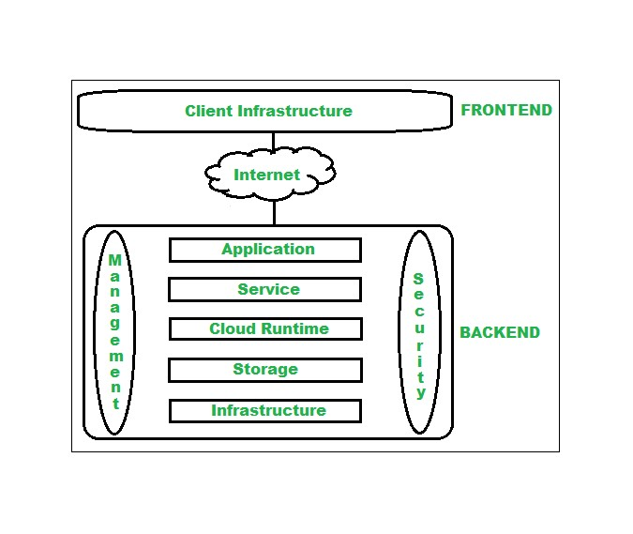

**ProThe diagram represents a cloud-based technical architecture showing how the frontend (client infrastructure) interacts with the backend (cloud services) through the internet.**

**It explains the layered structure of an application environment, where the frontend is the user-facing part, and the backend handles processing, storage, and infrastructure.**

**Project Goals and Objectives:**

The primary goal of this project is to design and implement a family expense management system using ServiceNow that allows households to record, categorize, calculate, and analyze their daily, monthly, and annual expenses in a centralized and automated way. By leveraging ServiceNow’s workflow automation, reporting, and dashboard capabilities, the system aims to simplify financial tracking, reduce manual effort, and provide families with accurate insights for better budgeting and decision- making .

1.Centralized Expense Recording :

□ Create a ServiceNow application where all family members can input their expenses under predefined categories (food, rent, utilities, healthcare, education, etc.).

1. Automation of Calculations :

□ Implement business rules and workflows to automatically calculate total monthly expenses, averages, and savings potential without manual intervention.

1. Visualization and Reporting :

□ Use ServiceNow dashboards and reporting tools to generate charts, summaries, and monthly comparison reports for better financial analysis.

1. Budget Monitoring and Alerts :

□ Set budget thresholds for each category and trigger notifications when expenses exceed the limit.

1. Data Transparency and Accessibility :

□ Provide a user-friendly system where all family members can view and track expenses, ensuring transparency and accountability.

1. Improved Financial Planning :

□ Help families identify spending patterns, reduce unnecessary costs, and plan for future savings effectively.

**Features of Calculating Family Expenses using ServiceNow :**

1. **Custom Expense Categories:**

**◆ Ability to create and manage expense categories such as food, rent, transport, utilities, healthcare, education, and entertainment.**

1. **Easy Data Entry Forms:**

**◆ Simple ServiceNow forms for family members to log daily or monthly expenses directly into the system.**

1. **Automated Expense Calculations:**

**◆ Business rules and workflows automatically calculate total expenses, averages, and category-wise breakdowns.**

1. **Budget Tracking and Alerts:**

**◆ Option to set monthly or category-wise budget limits with notifications triggered when spending exceeds thresholds.**

1. **Real-Time Dashboards:**

**◆ Visual dashboards showing pie charts, bar graphs, and trend analysis of expenses for better financial insights.**

**PRE-REQUISITES**:

Here are the key prerequisites for developing a frontend application using ☆ ServiceNow Instance & Access :

Personal Developer Instance (PDI): You'll need access to a ServiceNow PDI—a free, cloud-hosted sandbox ideal for developing, testing, and experimenting without impacting production systems. Setting it up is straightforward and can be done via the ServiceNow Developer Program.

Active Use Requirement: Keep your instance active; PDIs may be reclaimed if inactive for about 10 days.

☆ Foundational Knowledge

Platform Familiarity: Basic understanding of ServiceNow navigation and modules, such as tables, forms, workflows, and dashboards, is recommended to jumpstart development.

JavaScript & Scripting: Knowledge of JavaScript is important for writing automation logic like business rules and client scripts.

☆ 3 Application Development Tools

App Engine Studio or Studio IDE: Use these integrated development environments within ServiceNow to build your custom application, including forms, workflows, dashboards, and script includes.

☆ Learning & Certification (Optional but Helpful)

Training Courses: Formal courses like Application Development Fundamentals (and ideally Scripting Fundamentals) help deepen your understanding and ease development.

Application Development Fundamentals is critical for structured training and may include exam vouchers for certification.

Certification Prerequisites: For the Certified Application Developer (CAD) certification, it’s beneficial to have at least six months of handson experience building applications in ServiceNow.

☆ Hardware & Tools

Basic Requirements: A computer with stable internet access and a modern web browser (e.g., Chrome or Firefox) is sufficient since ServiceNow is cloud-based.

For on-premise scenarios (rare in personal projects), more detailed hardware specs would be needed—but these apply mainly to enterprise installations.

**Access the App:**

* Go to the official ServiceNow Developer portal: https://developer.servicenow.com.
* Sign up with your email and verify your account.
* Access on Mobile (Optional):
* Download the ServiceNow Mobile App from Google Play or App Store.
* Log in with your instance URL and credentials to view and enter expenses from your phone.
* You have successfully installed and set up the application on your local machine. You can now proceed with further customization, development, and testing as needed.

**Project structure:**

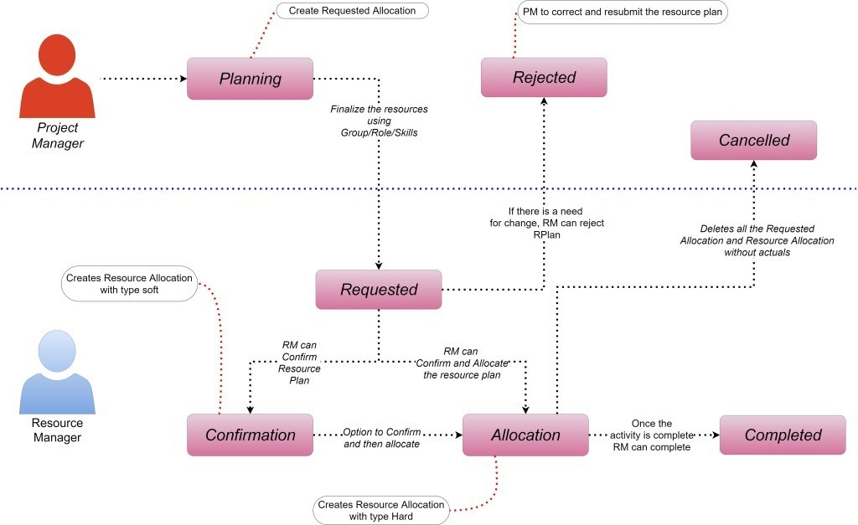

The diagram represents a Resource Allocation Workflow in ServiceNow. It illustrates how a project manager and a resource manager interact in the process of requesting, confirming, allocating, and completing resource plans. Each stage (Planning, Requested, Confirmation, Allocation, Completed, Rejected, Cancelled) shows possible outcomes of the request, along with the decision-making flow between the stakeholders.

It ensures that resources are properly requested, reviewed, approved/rejected, and tracked until the work is completed.

**Project Flow:**

1. **Planning (Project Manager)**
   * **The Project Manager (PM) creates a requested allocation for resources.**
   * **Resources are finalized based on Group/Role/Skills.**
2. **Requested**
   * **The allocation request moves into the Requested state.**
   * **At this stage, the Resource Manager (RM) reviews the resource plan.**
3. **Decision Points**
   * **Rejected: If the RM finds issues with the resource plan, they can reject it. The PM must correct and resubmit.**
   * **Cancelled: If the request is no longer valid, all allocations without actuals can be deleted.**
4. **Confirmation (Resource Manager)**
   * **The RM can confirm the resource plan (soft allocation).**
   * **This gives an option to confirm resources before final allocation.**
5. **Allocation**
   * **The RM confirms and allocates resources (hard allocation).Resources are formally assigned to the project.**
6. **Completed**

**★ Once the activity or task is completed, the RM can mark it as complete.This closes the allocation cycle.**

User Interface snips:

1.Login / Home Page

* Shows how users (family members) log in to ServiceNow.
* Dashboard view with navigation to “Family Expenses”

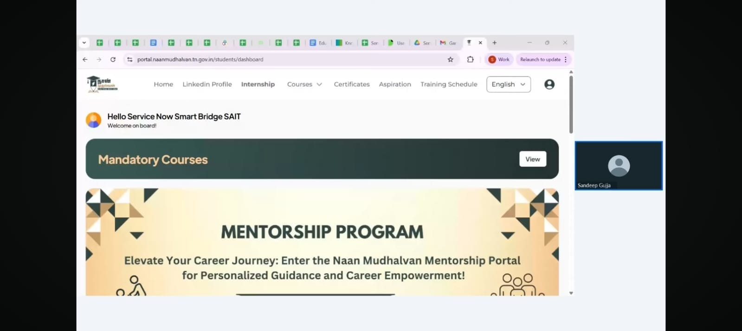

2. Expense Entry Form ● Fields like:

* Date
* Expense Category (Food, Transport, Education, Bills, etc.)
* “Submit” button to save expense.

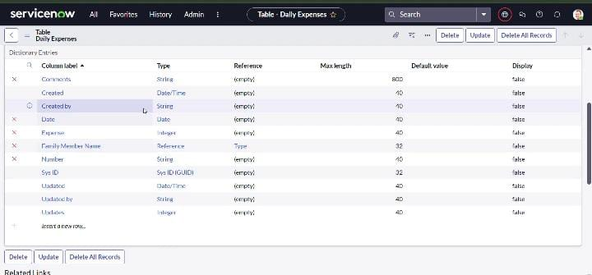

3. Expense List View

* A table showing all recorded expenses.
* Columns: Date, Category, Amount, Added By, Status.
* Filters for searching expenses by month or category.

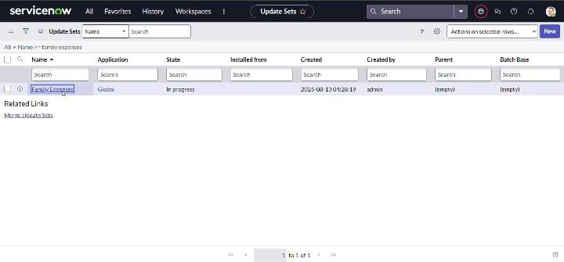

4. Expense Dashboard / Reports

* Pie chart: Expense split by category.
* Bar graph: Monthly expense comparison.
* Line chart: Trend of spending over time.

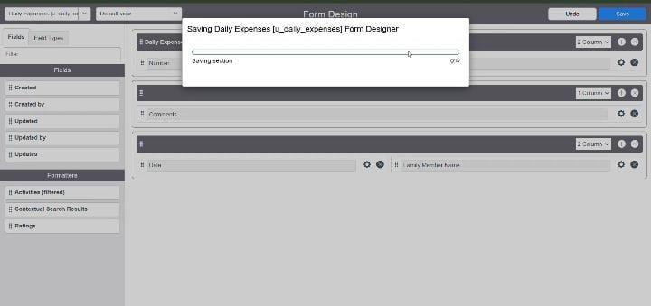

5. Notifications / Alerts

* Pop-up or email notification if monthly expense crosses the set budget.
* Example: “Alert: Your Food budget exceeded by ₹500 this month.”

Project demo link: https://drive.google.com/file/d/18d5Y_WnixyPlhNzltLRBev1PEU3muEFk/view?usp=drivesdk